TABLA DE INTEGRALES
Función | Integral
y = c | c.x +k
y = c.x | 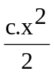 +k
y = 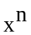 | 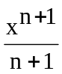 +k
y = 1/x | ln |x| +k
y = sen x | -cos x +k
y = cos x | sen x +k
y = tg x | - ln |cos x| +k
y = ctg x | ln |sen x | +k
y = sec x | 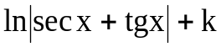
y = cosec x | +k
y = arcsen x | 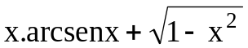+k
y = arccos x | 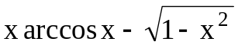+k
y = arctg x | 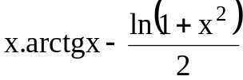+k
y = arcctg x | 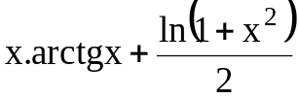+k
y = sh x | ch x+k
y = ch x | sh x+k
y = th x | ln( ch x) +k
y = coth x | ln( sh x) +k
y = sen (kx) | 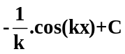
y = cos (kx) | 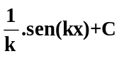
y = e^{x} | 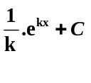
y = ln x | x.(ln x - 1) +k
y = e^{x} | e^{x} +k
y = a^{x} | 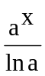+ k

